1. 
2. We looked at request so far and understood what URIs are, how to design them and what and which HTTP methods to use.
3. Let’s switch our focus to responses.
4. 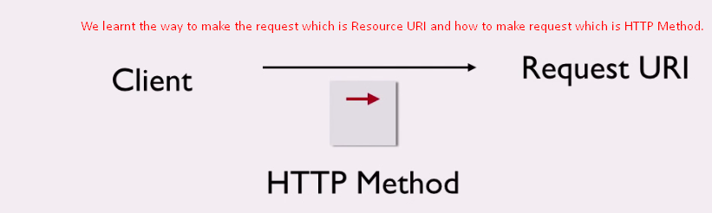
5. 
6. 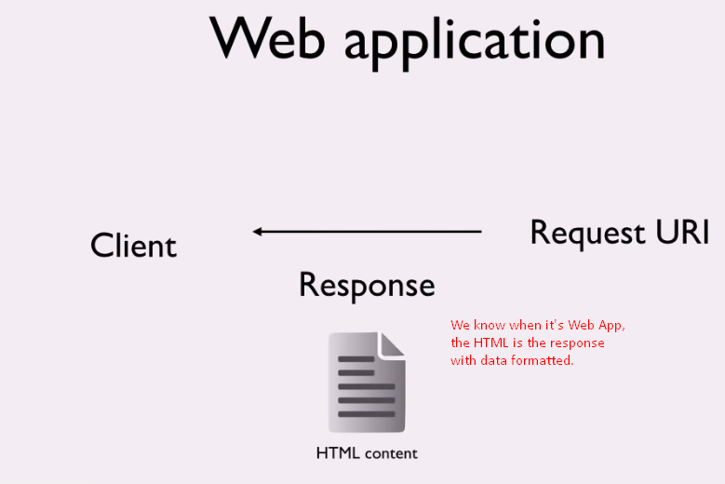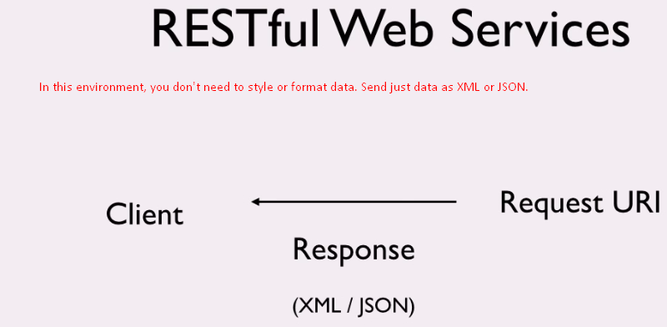  
   We have discussed some data formats such as JSON, XML.   
   JSON has got recently much popularity as it’s less verbose and much more compact as compared to XML.

Secondly, More than not (usually), the client is browser too which is good at consuming JSON data by converting it into javascript object.  
Considering all these advantages, we will use JSON for our messenger app as response.

1. Let’s see at the format itself. 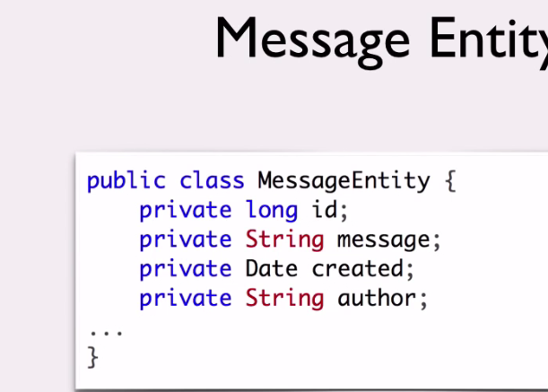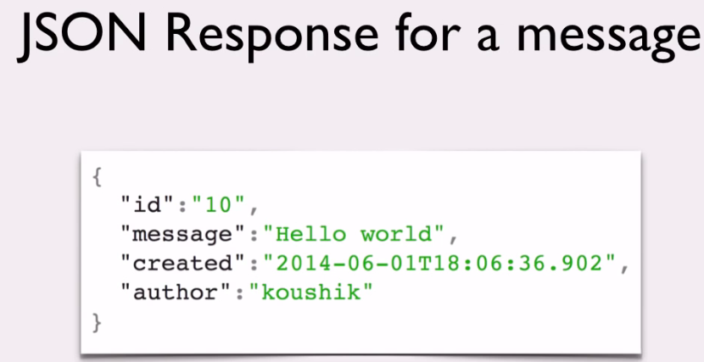
2. 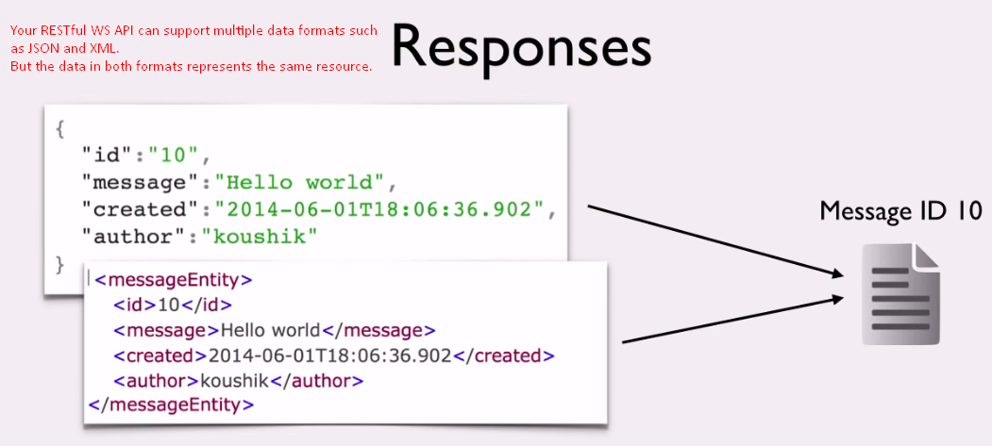  
   Either JSON or XML, the response in different representations for same resource.   
   It’s very important to understand that when you making RESTful API call, you’re **sending or receiving representation of the resource**.   
   Different representation could have different formats, even though the underlying resource is the same.   
   This is actually REST gets its name. It stands for “**Representational State Transfer**”. 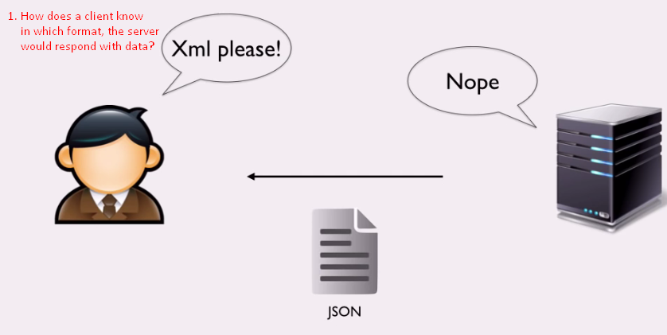
3. **Answer**: Using HTTP-Headers.
4. 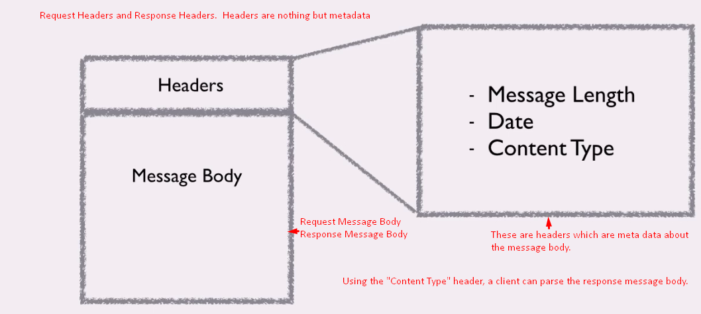
5. 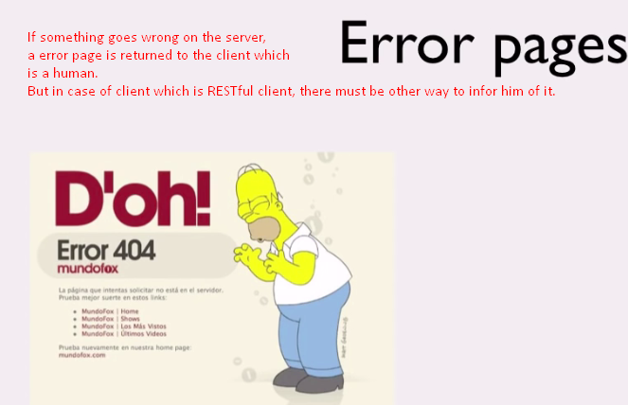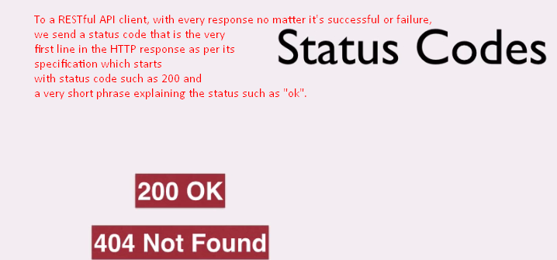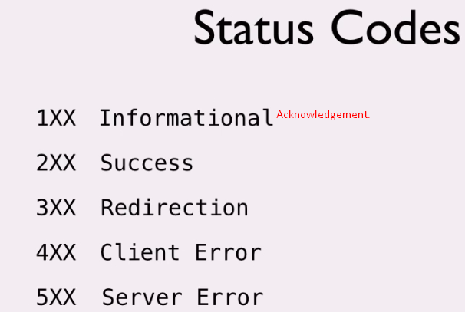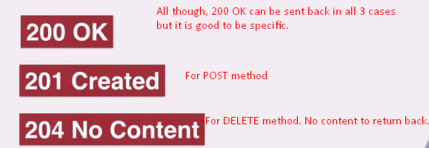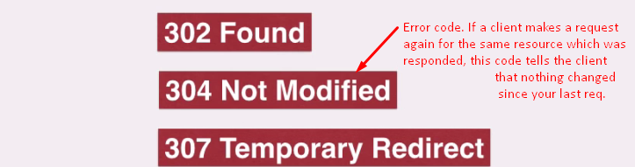
6. 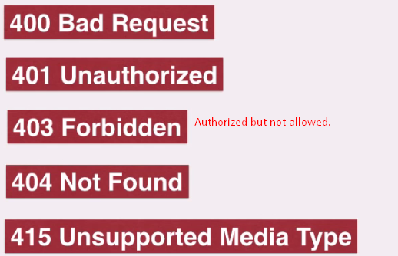
7. 